**5.0 Financial Analysis & Comparison**

**5.1 Overview Summary of Financial Statements**

This section gives an overview analysis of the key financial data. Further performance details and comparison of each core business will be covered in Sections 5.2 to 5.5. Data of up to 10 years may be presented but major focus will be put in the last 5 years from 2010 to 2014 in the analysis.

**5.1.1 Ten-Year Key Statistics**

| in HK$ million | 2014 | 2013 | 2012 | 2011 | 2010 | 2009 | 2008 | 2007 | 2006 | 2005 |
| --- | --- | --- | --- | --- | --- | --- | --- | --- | --- | --- |
| **Consolidated Profit and Loss Account** |  |  |  |  |  |  |  |  |  |  |
| Turnover | 40,156 | 38,707 | 35,739 | 33,423 | 29,518 | 18,797 | 17,628 | 10,690 | 9,541 | 9,153 |
| Operating profit before depreciation, amortisation and variable annual payment | 19,639 | 15,795 | 16,133 | 17,058 | 14,951 | 13,069 | 14,009 | 14,229 | 11,032 | 11,259 |
| Depreciation and amortisation | 3,485 | 3,372 | 3,208 | 3,206 | 3,120 | 2,992 | 2,944 | 2,752 | 2,688 | 2,695 |
| Interest and finance charges | 545 | 732 | 879 | 921 | 1,237 | 1,504 | 1,998 | 1,316 | 1,398 | 1,361 |
| Investment property revalation gain/loss | 4,035 | 4,425 | 3,757 | 5,088 | 4,074 | 2,798 | -146 | 8,011 | 2,178 | 2,800 |
| Profit for the year | 15,797 | 13,208 | 13,514 | 15,688 | 12,844 | 10,101 | 8,035 | 16,584 | 8,139 | 8,953 |
| Profit attributable to equity shareholders arising from underlying businesses | 11,571 | 8,600 | 9,618 | 10,468 | 8,657 | 7,300 | 8,185 | 8,571 | 5,962 | 6,140 |
| Dividend proposed and declared | 6,116 | 5,335 | 4,575 | 4,396 | 3,405 | 2,977 | 2,715 | 2,522 | 2,328 | 2,299 |
| Earnings per share(HK$) | 2.69 | 2.25 | 2.31 | 2.69 | 2.21 | 1.77 | 1.43 | 2.98 | 1.48 | 1.65 |
| **Consolidated Balance Sheet(HK million $)** |  |  |  |  |  |  |  |  |  |  |
| Total assets | 227,152 | 215,823 | 206,687 | 197,684 | 181,660 | 176,492 | 159,345 | 155,668 | 120,421 | 113,666 |
| Loans, other obligations and bank overdrafts | 20,507 | 24,511 | 23,577 | 23,168 | 21,057 | 23,868 | 31,289 | 34,050 | 28,152 | 28,264 |
| Obligations under service concession | 10,614 | 10,658 | 10,690 | 10,724 | 10,749 | 10,625 | 10,656 | 10,685 | - | - |
| Deferred income | 765 | 623 | 488 | 403 | 605 | 167 | 156 | 515 | 1,682 | 3,584 |
| Total equity attributable to equity shareholders | 163,325 | 152,577 | 142,904 | 131,907 | 121,914 | 110,479 | 101,431 | 94,889 | 79,242 | 71,969 |
| **Financial Ratios(%)** |  |  |  |  |  |  |  |  |  |  |
| Operating margin(%) | 38.4 | 37.2 | 36.1 | 36.3 | 37 | 50.6 | 53 | 55.4 | 54.7 | 55.9 |
| Operating margin (excluding Mainland of China and international subsidiaries)(%) | 53.1 | 53.4 | 53.6 | 55.6 | 55.1 | 53.8 | 53.2 | 55.9 | 55.3 | 55.9 |
| Net debt-to-equity ratio (%) | 7.6 | 11.8 | 11 | 11.6 | 12.3 | 24.9 | 40.6 | 46.5 | 35.1 | 38.8 |
| Interest cover (times) | 15.2 | 11.5 | 13 | 14.5 | 10.5 | 7.1 | 6 | 9 | 6.7 | 7.6 |

*Table 1: Ten-year key statistics [1]*

The ten-year statistics, which is shown in *Table 1*, co-relate to the major events of MTRC in the past. Turnover grew steadily over the last 10 years with a significant rise in 2008 due to the merging with Kowloon-Canton Railway Corporation (KCRC) which brought over 60% of increase in revenue. The figure kept on rising in subsequent years with new extension lines coming into service (e.g. West Island Line), improving of operation efficiency after merging, and good performance of its properties & station commercial businesses.

Meanwhile, an increase in loans was observed when the rail merger plan started in 2007. A drop in profit was, however, recorded in 2008 which was caused by the bad performance of property sale under the impact of global financial turmoil. That was also reflected in the negative figure of investment property revaluation in the same year.

Over the next few years, with a series of optimistic reasons (including reduction of interest rate in the global market, cash surplus from operating activities, and receipt of government funding support), MTRC was able to decrease the net debt-to-equity ratio from over 40% in 2008 to under 10% in 2014.

In 2010, a new railway subsidiary in Mainland of China commenced operations. However, due to the lower than expected performance of Shenzhen Metro (SZMTR) and Mass Transit Railway Stockholm (MTRS), the operating margin dropped from 50.6% in 2009 down to 37% in 2010. Excluding the Mainland of China and international subsidiaries, MTRC's operating margin remained steady at above 50%.

Amount of total assets increased steadily since 2009 mainly due to investment property revaluation gains under the uptrend of property market, capitalisation of construction costs of various railway extension projects (e.g. Shenzhen Line 4, West Island Line, South Island Line (East), Kwun Tong Line etc.), and property development in progress.

The interest cover remained at the range of 15.2 to 10.5 in the last 5 years. It shows that interest expense is only a small portion of earnings before interest & taxes. Together with a low net debt-to-equity ratio, MTRC can take further loan for business expansion to generate further income without much trouble in meeting interest payment.

**5.1.2 Consolidated Balance Sheet**

| in HK$ million | At 31 December 2014 | At 31 December 2013 | At 31 December 2012 | At 31 December 2011 | At 31 December 2010 |
| --- | --- | --- | --- | --- | --- |
| **Assets** |  |  |  |  |  |
| Fixed assets |  |  |  |  |  |
| – Investment properties | 65,679 | 61,285 | 55,314 | 51,453 | 45,314 |
| – Other property, plant and equipment | 78,279 | 76,277 | 76,088 | 76,687 | 77,276 |
| – Service concession assets | 26,698 | 25,594 | 24,492 | 23,928 | 21,467 |
|  | 170,656 | 163,156 | 155,894 | 152,068 | 144,057 |
| Property management rights | 30 | 31 | 31 | 31 | 31 |
| Railway construction in progress | 16,229 | 11,548 | 7,458 | 3,566 | N/A |
| Property development in progress | 7,490 | 11,233 | 10,430 | 11,964 | 9,128 |
| Deferred expenditure | 64 | 4 | 15 | 14 | 1,079 |
| Interests in non-controlled subsidiaries | N/A | N/A | 433 | 579 | 541 |
| Interests in associates | 5,797 | 5,277 | 3,825 | 948 | 836 |
| Deferred tax assets | 50 | 29 | 21 | 24 | 9 |
| Investments in securities | 527 | 472 | 393 | 2,974 | 3,912 |
| Properties held for sale | 1,076 | 1,105 | 3,016 | 3,757 | 1,936 |
| Derivative financial assets | 105 | 115 | 256 | 344 | 375 |
| Stores and spares | 1,365 | 1,281 | 1,220 | 1,135 | 1,061 |
| Debtors, deposits and payments in advance | 3,797 | 3,621 | 4,474 | 3,964 | 3,061 |
| Loan to a property developer | N/A | N/A | N/A | N/A | 1,975 |
| Amounts due from related parties | 1,073 | 654 | 785 | 402 | 330 |
| Cash, bank balances and deposits | 18,893 | 17,297 | 18,664 | 16,100 | 13,334 |
|  | 227,152 | 215,823 | 206,915 | 197,870 | 181,665 |
| **Liabilities** |  |  |  |  |  |
| Bank overdrafts | 46 | 47 | 55 | N/A | 16 |
| Short-term loans | 500 | N/A | 300 | N/A | 300 |
| Creditors and accrued charges | 16,421 | 13,793 | 15,119 | 16,402 | 15,491 |
| Current Taxation | 996 | 349 | 406 | 597 | 1,018 |
| Contract retentions | 1,094 | 986 | 948 | 643 | 404 |
| Amounts due to related parties | 1,607 | 1,388 | 1,061 | 1,481 | 892 |
| Loans and other obligations | 19,961 | 24,464 | 23,222 | 23,168 | 20,741 |
| Obligations under service concession | 10,614 | 10,658 | 10,690 | 10,724 | 10,749 |
| Derivative financial liabilities | 565 | 389 | 132 | 151 | 148 |
| Loan from holders of non-controlling interests | 124 | 135 | 157 | 154 | 154 |
| Deferred income | 765 | 623 | 488 | 403 | 605 |
| Deferred tax liabilities | 10,977 | 10,289 | 9,857 | 9,498 | 13,854 |
|  | 63,670 | 63,121 | 62,435 | 63,221 | 64,372 |
| **Net assets** | 163,482 | 152,702 | 144,480 | 134,649 | 117,293 |
|  |  |  |  |  |  |
| **Capital and reserves** |  |  |  |  |  |
| Share capital and other statutory capital reserves | 45,280 | 44,442 | 44,281 | 44,062 | 43,734 |
| Other reserves | 118,045 | 108,115 | 99,992 | 90,401 | 73,416 |
| **Total equity attributable to equity shareholders of the Company** | 163,325 | 152,557 | 144,273 | 134,463 | 117,150 |
| **Non-controlling interests** | 157 | 145 | 207 | 186 | 143 |
| **Total equity** | 163,482 | 152,702 | 144,480 | 134,649 | 117,293 |

*Note: The items highlighted in pale green are assumed to be "current" in nature according to the limited amount of information provided.*

*Table 2: Consolidated Balance Sheet for the last 5 years [1]*

*Table 2* shows the breakdown items of assets, liabilities, and equity. As reflected from the figures, the total liabilities of MTRC over the past 5 years remained stable at the range of $63 to $64 billion. Assets grew steadily with major contributions from gain in revaluation of investment properties & service concession assets, progress of railway extension projects, and rising amount of cash holding. Capital of the business is mainly allocated in fixed assets including investment properties, other property, plant & equipment, and service concession assets. MTRC demonstrate a very strong overall financial position with reserves rising solidly year from year. It makes good use of profits & government funding in expansion to obtain further earnings.

|  | 2014 | 2013 | 2012 | 2011 | 2010 |
| --- | --- | --- | --- | --- | --- |
| Current Assets (in HK$ million) | 26,836 | 24,545 | 28,808 | 28,676 | 25,984 |
| Current Liabilities (in HK$ million) | 20,135 | 15,966 | 17,073 | 18,631 | 17,865 |
| Working Capital (in HK$ million) | 6,701 | 8,579 | 11,735 | 10,045 | 8,119 |
| Current Ratio | 1.33 | 1.54 | 1.69 | 1.54 | 1.45 |
| Quick Ratio | 1.21 | 1.39 | 1.44 | 1.28 | 1.29 |
| Debt Ratio | 0.28 | 0.29 | 0.30 | 0.32 | 0.35 |

*Table 3: Analysis on financial status for the last 5 years*

To further look into the liquidity status of MTRC, a number of ratios are calculated and presented in *Table 3*. The company was able to maintain a healthy level of working capital over the past. The current ratio stayed at the range of 1.33 - 1.69 while the debt ratio dropped from 0.35 in 2010 to 0.28 in 2014. That means MTRC has sufficient current asset to meet its current liability with some buffer and debt is only accountable for just around 28 - 35% of its total asset. Although there is a decreasing trend of working capital in the last couple of years, with a number of new extension lines completing in the next few years, revenue from railway operation and station commercial business will rise brining into additional cash to the business. In the event of extreme case, the quick ratio of above 1 indicates that MTRC is able to pay off its short-term creditors without much trouble. Overall, MTRC manages a good use of financial leverage without over-exploiting its position causing any liquidity problem.

**5.1.3 Consolidated Profit and Loss**

| For the year ended 31 December in HK$ million | 2014 | 2013 | 2012 | 2011 | 2010 |
| --- | --- | --- | --- | --- | --- |
| Revenue from Hong Kong transport operations | 16,223 | 15,166 | 14,523 | 13,509 | 12,635 |
| Revenue from Hong Kong station commercial businesses | 4,963 | 4,588 | 3,680 | 3,422 | 2,853 |
| Revenue from Hong Kong property rental and management businesses | 4,190 | 3,778 | 3,401 | 3,083 | 2,961 |
| Revenue from Mainland of China and international subsidiaries | 12,627 | 13,246 | 12,786 | 12,411 | 10,144 |
| Revenue from other businesses | 2,153 | 1,929 | 1,349 | 998 | 925 |
|  | 40,156 | 38,707 | 35,739 | 33,423 | 29,518 |
| Expenses relating to Hong Kong transport operations |  |  |  |  |  |
| – Staff costs and related expenses | -4,450 | -4,198 | -3,879 | -3,673 | -3,398 |
| – Energy and utilities | -1,409 | -1,293 | -1,200 | -1,110 | -1,067 |
| – Operational rent and rates | -269 | -259 | -234 | -199 | -184 |
| – Stores and spares consumed | -540 | -514 | -477 | -466 | -421 |
| – Maintenance and related works | -1,361 | -1,177 | -1,112 | -1,048 | -912 |
| – Railway support services | -253 | -246 | -210 | -206 | -207 |
| – General and administration expenses | -640 | -515 | -479 | -429 | -379 |
| – Other expenses | -314 | -247 | -238 | -223 | -253 |
|  | -9,236 | -8,449 | -7,829 | -7,354 | -6,821 |
| Expenses relating to Hong Kong station commercial businesses | -515 | -464 | -397 | -358 | -294 |
| Expenses relating to Hong Kong property rental and management businesses | -747 | -673 | -627 | -587 | -654 |
| Expenses relating to Mainland of China and international subsidiaries | -11,821 | -12,455 | -12,184 | -11,964 | -9,865 |
| Expenses relating to other businesses | -1,960 | -1,781 | -1,296 | -913 | -751 |
| Project study and business development expenses | -454 | -486 | -323 | -123 | -216 |
| **Operating expenses before depreciation, amortisation and variable annual payment** | -24,733 | -24,308 | -22,656 | -21,299 | -18,601 |
|  |  |  |  |  |  |
| **Operating profit before Hong Kong property development, depreciation, amortisation and variable annual payment** |  |  |  |  |  |
| – Arising from recurrent businesses | 15,478 | 14,399 | 13,083 | 12,124 | 10,917 |
| – Arising from Mainland of China property development | -55 | N/A |
|  | 15,423 | 14,399 | 13,083 | 12,124 | 10,917 |
| Profit on Hong Kong property development | 4,216 | 1,396 | 3,238 | 4,934 | 4,034 |
| **Operating profit before depreciation, amortisation and variable annual payment** | 19,639 | 15,795 | 16,321 | 17,058 | 14,951 |
| Depreciation and amortisation | -3,485 | -3,372 | -3,208 | -3,206 | -3,120 |
| Variable annual payment | -1,472 | -1,247 | -883 | -647 | -45 |
| **Operating profit before interest and finance charges** | 14,682 | 11,176 | 12,230 | 13,205 | 11,786 |
| Interest and finance charges | -545 | -732 | -879 | -921 | -1,237 |
| Investment property revaluation | 4,035 | 4,425 | 3,757 | 5,088 | 4,074 |
| Share of profit or loss of associates | 121 | 158 | 456 | 297 | 139 |
| **Profit before taxation** | 18,293 | 15,027 | 15,564 | 17,669 | 14,762 |
| Income tax | -2,496 | -1,819 | -1,893 | -1,981 | -2,590 |
| **Profit for the year** | 15,797 | 13,208 | 13,671 | 15,688 | 12,172 |
|  |  |  |  |  |  |
| **Attributable to:** |  |  |  |  |  |
| – Equity shareholders of the Company | 15,606 | 13,025 | 13,532 | 15,556 | 12,059 |
| – Non-controlling interests | 191 | 183 | 139 | 132 | 113 |
| **Profit for the year** | 15,797 | 13,208 | 13,671 | 15,688 | 12,172 |
|  |  |  |  |  |  |
| **Profit for the year attributable to equity shareholders of the Company:** |  |  |  |  |  |
| – Arising from underlying businesses before property development | 8,024 | 7,437 | 7,071 | 6,243 | 5,397 |
| – Arising from property development | 3,547 | 1,163 | 2,704 | 4,225 | 3,260 |
| – Arising from underlying businesses | 11,571 | 8,600 | 9,775 | 10,468 | 8,657 |
| – Arising from investment property revaluation | 4,035 | 4,425 | 3,757 | 5,088 | 3,402 |
|  | 15,606 | 13,025 | 13,532 | 15,556 | 12,059 |

*Table 4: Consolidated profit and loss account for the last 5 years [1]*

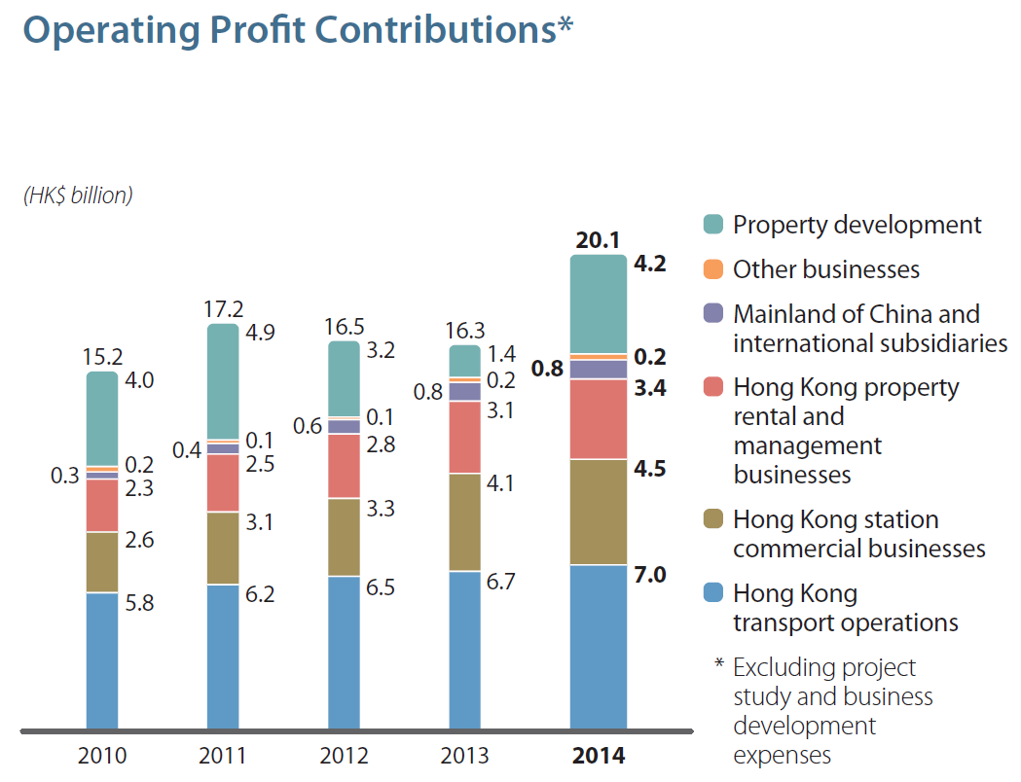

*Figure 1: Operating profit contributions with expenses in project study and business development excluded [1]*

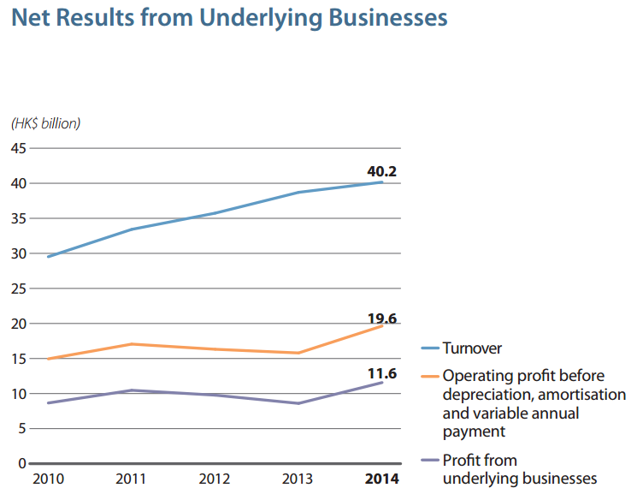

*Figure 2: Net results from underlying businesses [1]*

*Table 4* shows the breakdown revenue and expenses of each major business operations of MTRC. Revenue rose steadily over the last 5 years from HK$29.5 billion to HK$40.1 billion. With the rising expenses, profit remained at similar level till 2014 where an improvement was observed (see *Figure 2*). As reflected in *Figure 1*, major contributions of profit in dollar are HK transport operations, HK station commercial business, HK property rental & management businesses, and property development.

|  |  |  |  |  |  |
| --- | --- | --- | --- | --- | --- |
|  | 2014 | 2013 | 2012 | 2011 | 2010 |
| HK Transport Operation | 43% | 44% | 46% | 46% | 46% |
| HK Station Commercial Businesses | 90% | 90% | 89% | 90% | 90% |
| HK Property Rental and Management Businesses | 82% | 82% | 82% | 81% | 78% |
| Mainland of China and International Subsidiaries | 6% | 6% | 5% | 4% | 3% |
| Other Businesses | 9% | 8% | 4% | 9% | 19% |
| HK Property Development | N/A | N/A | N/A | N/A | N/A |

*Table 5: Rough estimation of operating margin for each major business section before depreciation and taxes*

The table above shows the rough estimation of profitability of each major business section of MTRC. Due to the lack of breakdown details, no estimation can be figured out for the HK property development. Both the HK station commercial businesses and HK property rental & management businesses give a high and stable profitability of around 80 - 90% as they make use of the space / facilities in the existing railway station and other assets to generate income while the associated costs are small. The HK transport operation also gives good profitability of above 40% with a mild drop in last 2 years. It is due to rising expenses and MTRC may consider to have tighter control over expenses or increase fare to cover them if it is allowed under the fare monitoring system. For Mainland of China & international subsidiaries and other businesses, their profitability is relative low, under 10% on average, compared with the rest. When appreciation, amortisation & variable annual payment is taken into account, their profitability may be even lower but still better than the interest rate offered by the bank when the business fund is put into term deposit. Nevertheless, improvement was observed in recent years for the Mainland of China and international subsidiaries. A thing that is worth attention is the significant drop in profitability for other businesses since 2011. Investigation may be necessary to understand the reason behind to come up with remedy solutions. Further details on the performance of each core business and comparison analysis will be discussed in later sections.

|  |  |  |  |  |  |
| --- | --- | --- | --- | --- | --- |
|  | 2014 | 2013 | 2012 | 2011 | 2010 |
| Return on Total Assets | 6.46% | 5.18% | 5.91% | 6.67% | 6.49% |
| Return on Equity | 9.66% | 8.65% | 9.46% | 11.65% | 10.38% |

*Table 6: Return of the overall business*

*Table 6* shows the return of the overall business over the last 5 years. The return on total assets stays in the level of 5.18 - 6.67% while the return on equity fluctuates in the range of 8.65 - 11.65%. There was a mild drop in 2012 - 2013 for both return indicators but picking up in 2014. Considering the risk of the business, this level of return is considered as reasonable when compared with the average performance of other major businesses listed in the Heng Seng Index 50 []. Some example figures are listed in the table below.

|  |  |  |
| --- | --- | --- |
|  | Return on Total Assets (%) | Return on Equity (%) |
| CLP Power | 4.69 | 12.80 |
| Henderson Land | 5.83 | 6.96 |
| China Merchants Group | 4.42 | 6.71 |
| Sinopec Corporation | 3.20 | 7.84 |

*Table 7: Return of a few major companies listed in HSI in 2014* []

**5.1.4 Consolidated Income Statement**

| for the year ended 31 December in HK$ million | 2014 | 2013 | 2012 | 2011 | 2010 |
| --- | --- | --- | --- | --- | --- |
| **Profit for the year** | 15,797 | 13,208 | 13,671 | 15,688 | 12,172 |
| **Other comprehensive income for the year (after taxation and reclassification adjustments):** |  |  |  |  |  |
| Items that will not be reclassified to profit or loss: |  |  |  |  |  |
| – Surplus on revaluation of self-occupied land and buildings | 116 | 298 | 339 | 471 | 285 |
| – Re-measurement of net liability of defined benefit plans | -370 | 686 | 0 | 0 | 0 |
|  | -254 | 984 | 339 | 471 | 285 |
| Items that may be reclassified subsequently to profit or loss: |  |  |  |  |  |
| – Exchange differences on translation of: |  |  |  |  |  |
| – financial statements of overseas subsidiaries and associates | -95 | 109 | 72 | 146 | 141 |
| – non-controlling interests | -26 | -35 | 3 | -1 | 16 |
| – Cash flow hedges: net movement in hedging reserve | 37 | -61 | 23 | -12 | -26 |
|  | -84 | 13 | 98 | 133 | 131 |
|  | -338 | 997 | 437 | 604 | 416 |
| **Total comprehensive income for the year** | 15,459 | 14,205 | 14,108 | 16,292 | 12,588 |
|  |  |  |  |  |  |
| **Attributable to:** |  |  |  |  |  |
| – Equity shareholders of the Company | 15,294 | 14,057 | 13,966 | 16,161 | 12,459 |
| – Non-controlling interests | 165 | 148 | 142 | 131 | 129 |
| **Total comprehensive income for the year** | 15,459 | 14,205 | 14,108 | 16,292 | 12,588 |

*Table 8: Consolidated comprehensive income statement for the last 5 years [1]*

Figures in the consolidated comprehensive income statement correspond to the profit & loss statement with no worrying entries observed. Management of MTRC may keep an eye on items like re-measurement of net liability of defined benefit plans, exchange rate difference of overseas subsidiaries to prevent any unexpected financial losses.

**5.1.5 Retained Earnings Statement**

|  |  |  |  |  |  |
| --- | --- | --- | --- | --- | --- |
| for the year ended 31 December in HK$ million | 2014 | 2013 | 2012 | 2011 | 2010 |
| **Balance as at 1 January (start of the current financial year)** | 104,965 | 95,832 | 85,506 | 71,781 | 62,705 |
| Profit for the current year | 15,606 | 13,025 | 13,375 | 15,556 | 12,059 |
| Other comprehensive income for the current year | -370 | 686 | 1,344 | 2,208 | 0 |
| Total comprehensive income for the current year | 15,236 | 13,711 | 14,719 | 17,764 | 12,059 |
| Final dividend of previous year | -3,886 | -3,130 | -2,951 | -2,598 | -2,177 |
| Interim dividend of the current year | -1,455 | -1,450 | -1,447 | -1,446 | -807 |
| Employee share options forfeited | 3 | 2 | 5 | 5 | 1 |
| **Balance as at 31 December (end of the current financial year)** | 114,863 | 104,965 | 95,832 | 85,506 | 71,781 |

*Table 9: Retained earnings for the last 5 years [1]*

As seen from the table above, with a stable level of profit, the retained earnings of MTRC in 2014 accumulated to $114,863 million which was a positive trend.

**5.1.6 Consolidated Cash Flow Statement**

| for the year ended 31 December in HK$ million | 2014 | 2013 | 2012 | 2011 | 2010 |
| --- | --- | --- | --- | --- | --- |
| **Cash flows from operating activities** |  |  |  |  |  |
| Cash generated from operations | 16,519 | 15,446 | 14,701 | 12,489 | 11,920 |
| Receipt of government subsidy for Shenzhen Metro Longhua Line operation | 652 | 661 | 637 | 638 | N/A |
| Current tax paid |  |  |  |  |  |
| – Hong Kong Profits Tax paid | -954 | -1,183 | -1,699 | -1,949 | -1,007 |
| – Mainland of China and overseas tax paid | -173 | -160 | -100 | -154 | -4 |
| **Net cash generated from operating activities** | 16,044 | 14,764 | 13,539 | 11,024 | 10,909 |
|  |  |  |  |  |  |
| **Cash flows from investing activities** |  |  |  |  |  |
| Capital expenditure |  |  |  |  |  |
| – Purchase of assets for Hong Kong transport and related operations | -2,889 | -2,790 | -2,327 | -2,102 | -1,953 |
| – Shenzhen Metro Longhua Line Project and related operations | -471 | -577 | -852 | -1,385 | -1,846 |
| – Island Line Extension Project | -2,760 | -2,537 | -2,897 | -3,111 | -3,218 |
| – South Island Line (East) Project | -2,611 | -3,283 | -2,480 | -1,467 | -347 |
| – Kwun Tong Line Extension Project | -969 | -1,029 | -976 | -450 | -190 |
| – Shenzhen Longhua Line Depot Property Development | -681 | -2,146 | N/A | N/A | N/A |
| – Hong Kong Property Development | -410 | -550 | -1,440 | -1,075 | -4,444 |
| – Investment property projects and fitting out work | -1,497 | -366 | -104 | -255 | -173 |
| – Other capital projects | -71 | -77 | -49 | -198 | -165 |
| Net cash (payment)/receipt in respect of entrustment works of Shatin to Central Link | N/A | N/A | -148 | 170 | 84 |
| Fixed annual payment | -750 | -750 | -750 | -750 | -750 |
| Variable annual payment | -1,247 | -883 | -647 | -45 | N/A |
| Receipts in respect of Hong Kong property development | 9,176 | 3,937 | 5,677 | 1,593 | 5,249 |
| Receipt of loan repayment from a property developer | N/A | N/A | N/A | 2,000 | N/A |
| Receipt of government grant for West Island Line Project | N/A | N/A | N/A | N/A | 12,252 |
| Decrease / (Increase) in bank deposits with more than three months to maturity when placed or pledged | 6,607 | 3,463 | -831 | -3,063 | -9,610 |
| Purchase of investments in securities | -177 | -192 | -260 | -160 | -3,844 |
| Proceeds from sale or redemption of investments in securities | 122 | 109 | 2,846 | 1,094 | 159 |
| Proceeds from disposal of fixed assets | 10 | 4 | 8 | 5 | 7 |
| Investment in an associate | -294 | -1,111 | -2,734 | N/A | N/A |
| Proceeds from disposal of an associate | N/A | 62 | N/A | N/A | N/A |
| Receipt of loan repayment from an associate | N/A | 24 | 24 | 29 | N/A |
| Settlement of loan repayment to an associate | N/A | N/A | N/A | -29 | N/A |
| Dividends received from and non-controlled subsidiaries and associates | 43 | 197 | 465 | 144 | 75 |
| **Net cash generated from/(used in) investing activities** | 1,131 | -8,495 | -7,475 | -9,055 | -8,714 |
|  |  |  |  |  |  |
| **Cash flows from financing activities** |  |  |  |  |  |
| Proceeds from shares issued under share option schemes | 377 | 136 | 186 | 34 | 63 |
| Drawdown of loans | 11,171 | 2,229 | 808 | 1,392 | 8,153 |
| Proceeds from issuance of capital market instruments | 543 | 3,248 | 5,998 | 2,198 | N/A |
| Repayment of loans | -10,205 | -918 | -6,319 | -1,111 | -5,390 |
| Repayment of capital market instruments | -5,158 | -3,336 | -102 | -500 | -5,778 |
| Interest paid | -791 | -967 | -727 | -603 | -861 |
| Interest received | 218 | 253 | 342 | 194 | 123 |
| Finance charges paid | -29 | -38 | -53 | -12 | -19 |
| Dividends paid to equity shareholders of the Company | -4,944 | -4,580 | -4,398 | -3,754 | -1,814 |
| Dividends paid to holders of non-controlling interests | -153 | -192 | -121 | -88 | -58 |
| **Net cash used in financing activities** | -8,971 | -4,165 | -4,386 | -2,250 | -5,581 |
| Net increase in cash and cash equivalents | 8,204 | 2,104 | 1,678 | -281 | -3,386 |
| Cash and cash equivalents at 1 January | 7,209 | 5,105 | 3,427 | 3,708 | 7,094 |
| Cash and cash equivalents at 31 December | 15,413 | 7,209 | 5,105 | 3,427 | 3,708 |

*Table 10: Consolidated cash flow statement for the last 5 years [1]*

The consolidated cash flow statement for the last 5 years is shown in the table above. The major sources of cash are operating activities and receipts in respect of HK property development. The major uses of cash are repayment of loans / capital market instruments and extension projects. Cash reserve in the business has been improved since 2012. This is due to the recent realisation of return from HK property development and less amount of cash being spent on property development & security purchase in recent years. Overall, the statement shows a healthy situation in cash flow.

**List of References**

1. MTRC Website: http://www.mtr.com.hk/en/corporate/investor/2014frpt.html
2. AA Stocks Website: http://www.aastocks.com/tc/stocks/market/index/hk-index-con.aspx?index=HSI&t=4&hk=0&s=1&o=1